**Unit 5: SQL Mini Project**

**GROUP 6: Damion Samuels, Narell Vasquez, Aaron Rodriguez**

Create Insurance Database

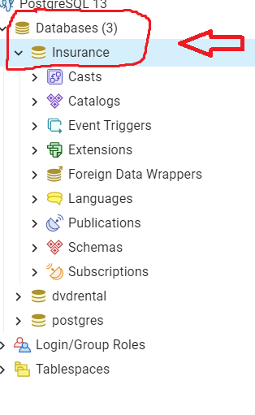

Create Insurance tables

1. Create Claims Table

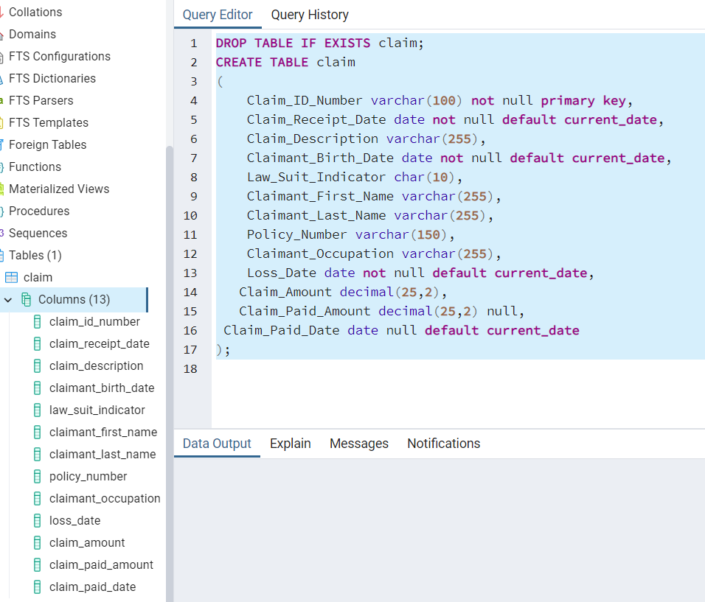

1. Create Customer Table

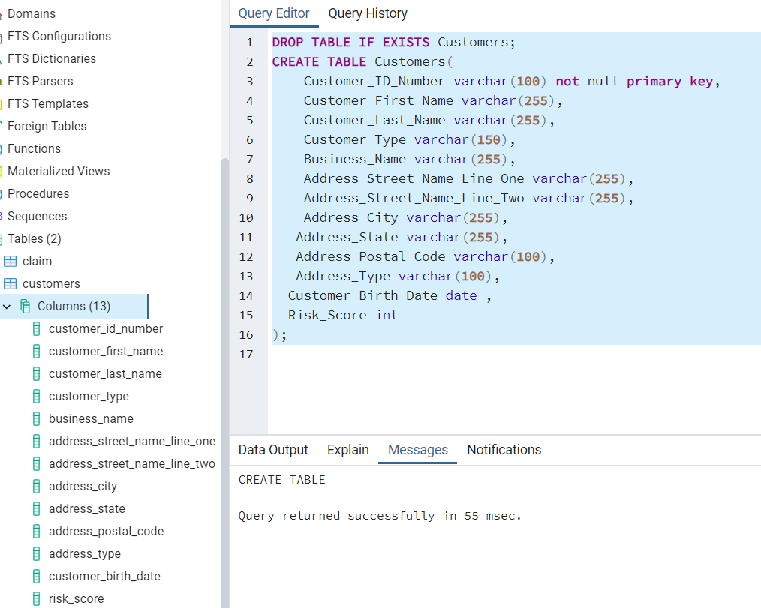

1. Create Policy Detail Table

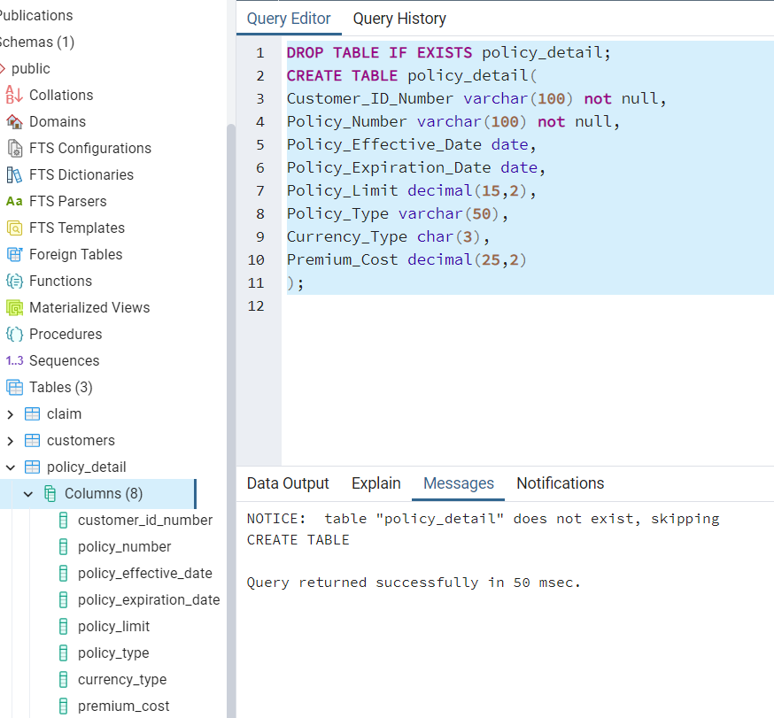

1. Create Reserves Table

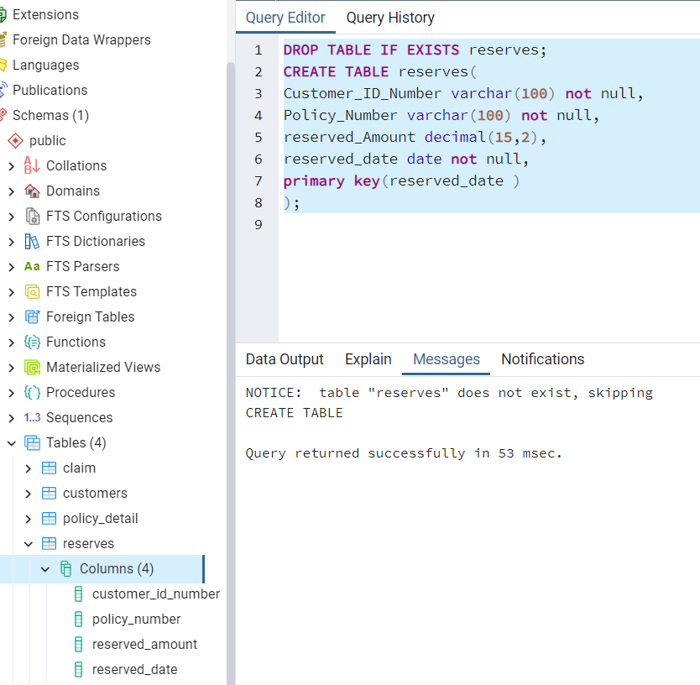

Insert script for each table

1. 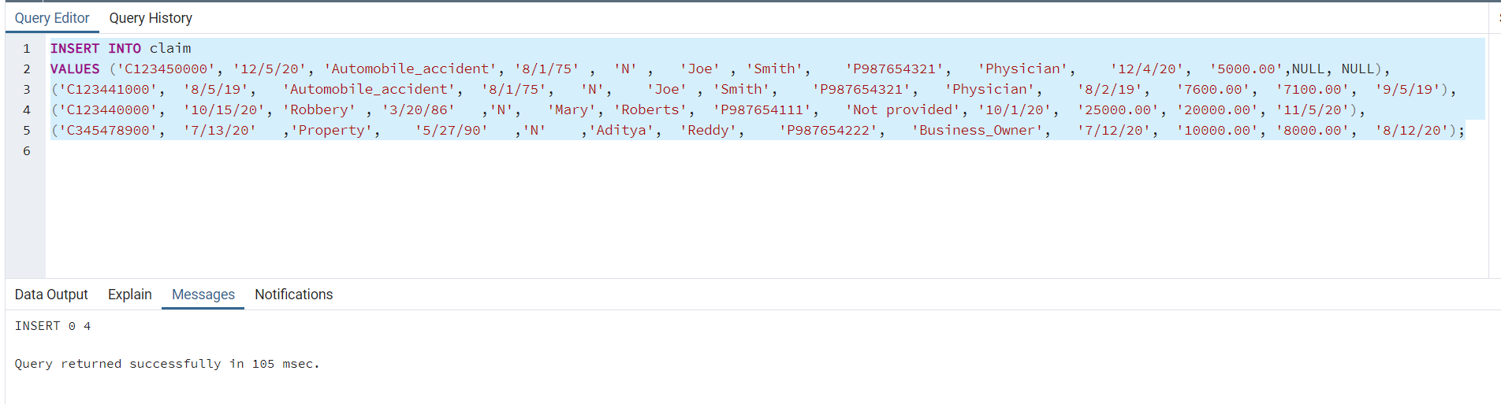Claim Insert script
2. 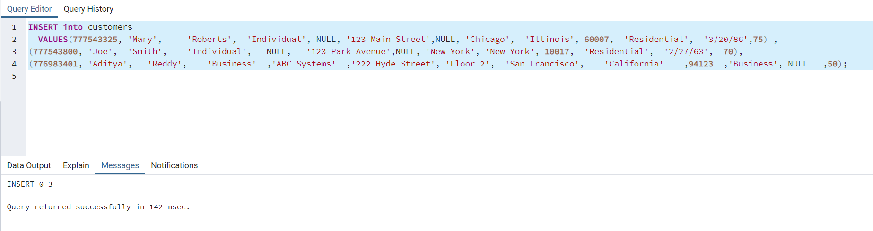Customers Insert script
3. 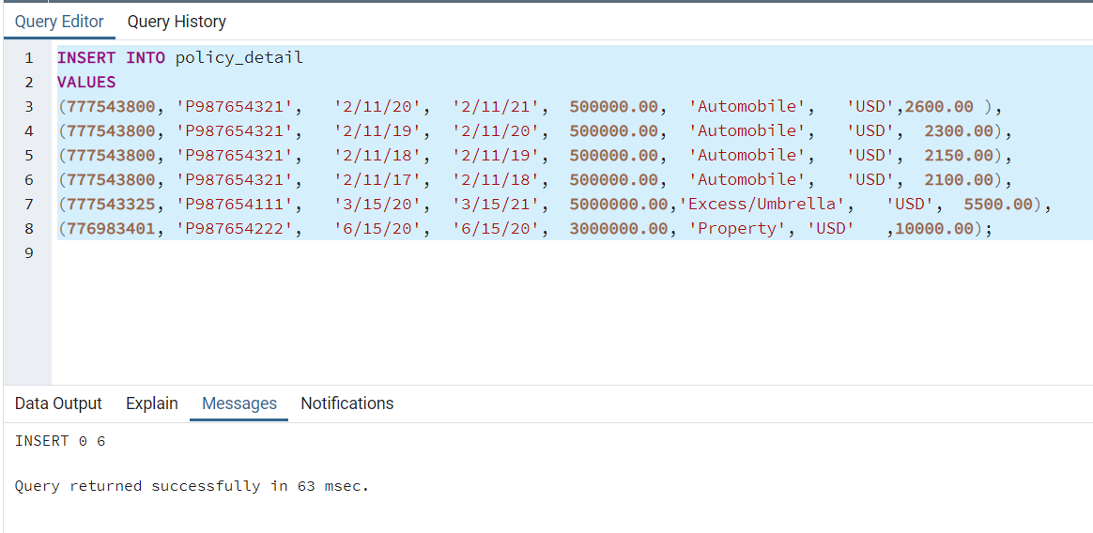Policy_detail Insert script
4. Reserves Insert script

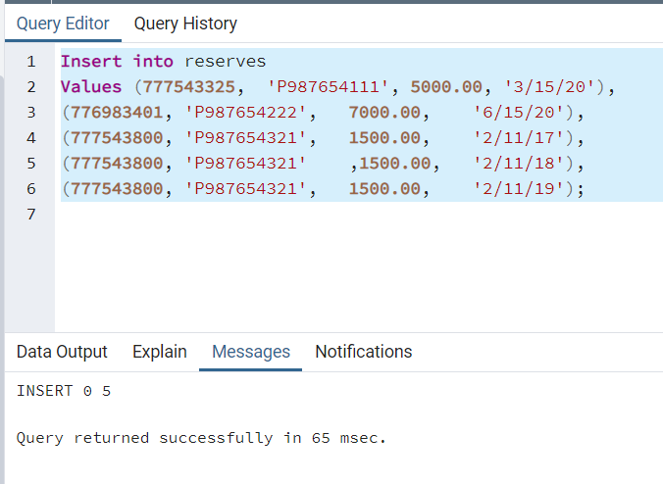

Populate Insurance tables with sample data which you created in above step.

Claim Table Populated

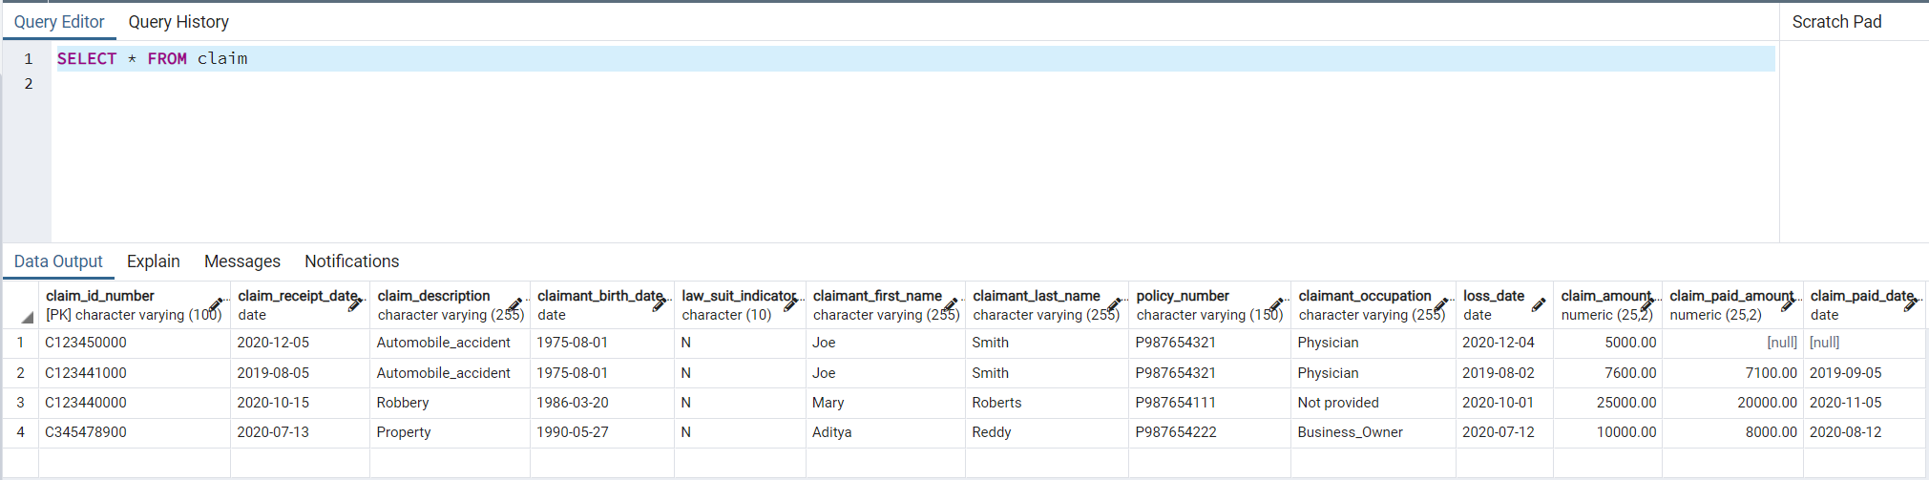

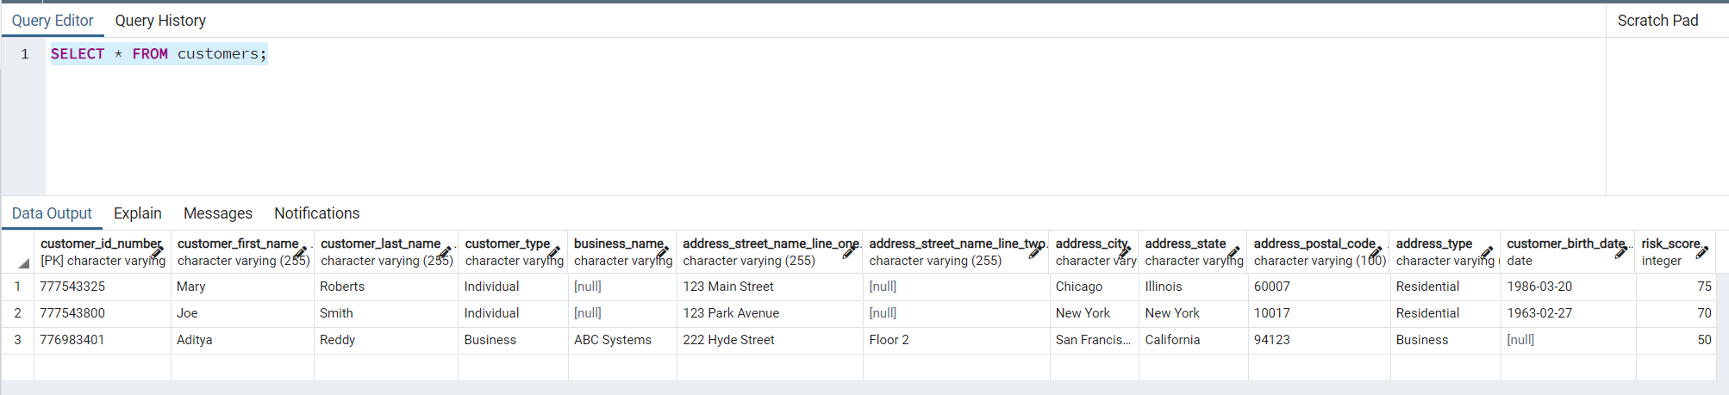Customers Table Populated

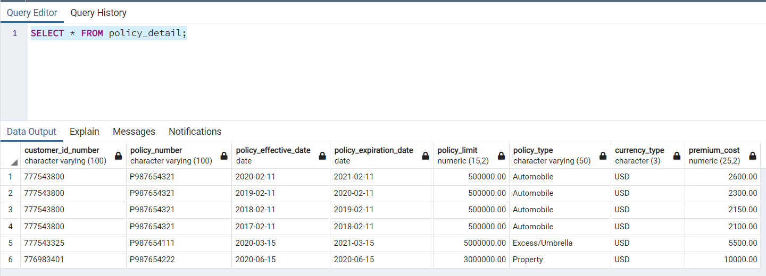Policy_detail Table Populated

Reserves Table Populated

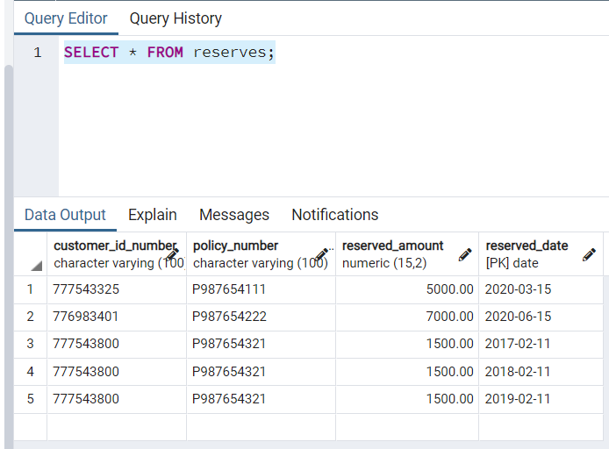

Form any 5 SQL to extract information from tables. Use Join, Where, Other conditional operators.

1. Find the total amount of paid claims that all claimants named Mary received

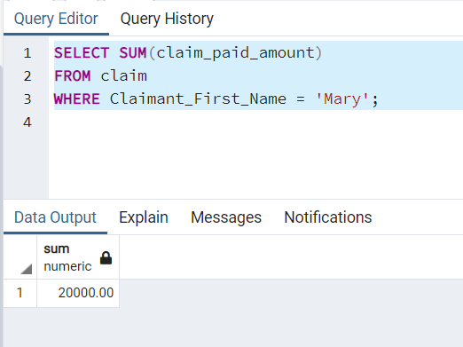

2. Show customers whose risk score is higher than 50

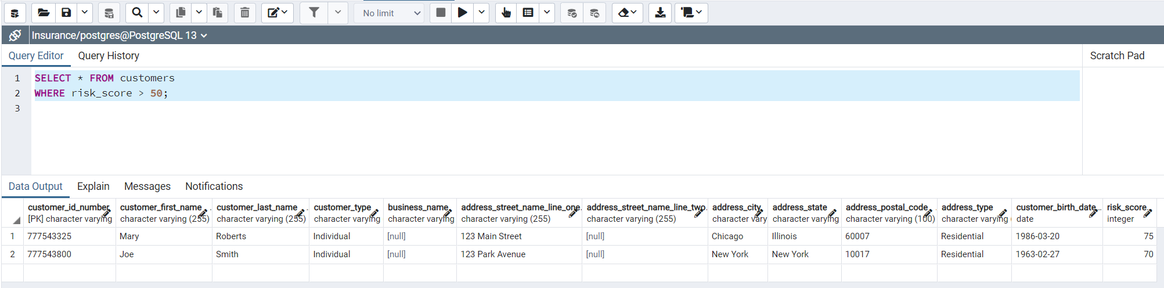

3. Find the common column on Customer1 Table and Reserves, and use the join command to join customer1 onto reserves.

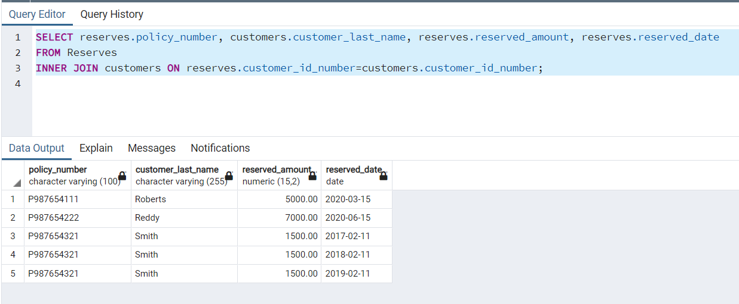

4. What is the customer id number who had a reserve date on 06/15/2020 ?

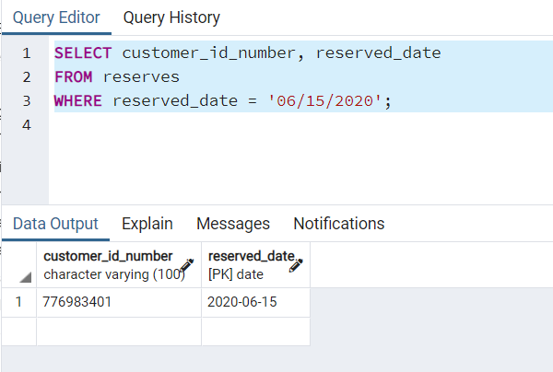

1. Full outer join claim and customer tables

